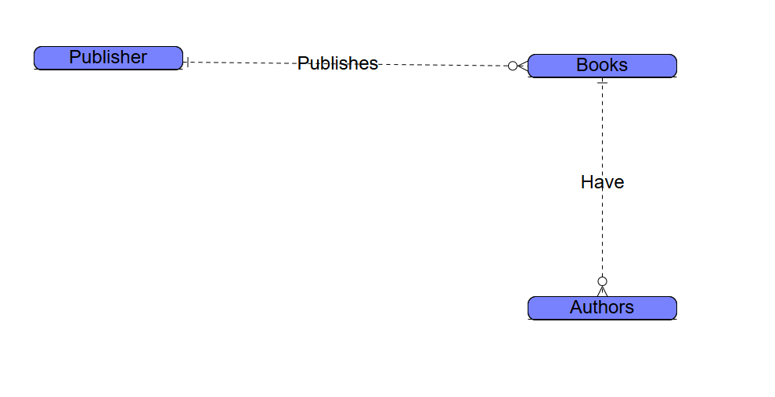

Jackson Webster

Module 2.2 Assignment